Model Comparison Supports the Pitcher Origin of *Utricularia* Suction Traps

Word count: 627

# Abstract

Carnivorous plants have been the subject of fascination and research in the almost 150 years since Darwin codified the subject in his book *Insectivorous Plants*. The origin of complex trapping mechanisms from structures adapted for photosynthesis is of particular interest. While Darwin and others put forward hypotheses for the origin of the Venus flytrap and other traps, the origin of the tiny and complex bladder traps of genus *Utricularia* has not been discussed in detail, despite *Utricularia* being the most diverse genus of carnivorous plants. The traps suck in prey in less than a millisecond, making this one of the fastest movements in the plant kingdom. In this research, we build a phylogenetic model for the evolution of carnivorous plant traps to test the “pitcher hypothesis” for the origin of the *Utricularia* trap, proposing a gradual evolutionary transition from simple adhesive traps to pitcher traps, and ultimately to *Utricularia*’s unique suction traps. We assembled phylogenetic trees for carnivorous plant species to test our hypothesis with statistical model comparison: the fit of a model where *Utricularia* bladder traps are essentially miniaturised pitcher traps is compared to less constrained null models where any trap type can evolve into any other. The results suggested that among the 18 phylogenetic models evaluated, the res7CTEaosb model, aligning with the pitcher hypothesis, emerged as the best-fitting model, with an AIC weight of 60%, and two other similar pitcher-hypothesis models garnering the remaining 40%. We propose that by statistically comparing models representing detailed, stepwise, pathways for the evolution of complex adaptations, we should be able to convert exercises in "adaptive storytelling," where verbal scenarios are subjectively judged on their plausibility, into the modern phylogenetic framework of statistical model comparison.

Introduction

For nearly 150 years since Darwin's *Insectivorous Plants*, carnivorous plants have “captivated” scientists and enthusiasts alike—not only for their remarkable ability to capture prey, but also for their extraordinary adaptations and unique ecological strategies. The remarkable ability of the Venus’ flytrap ('one of the most wonderful in the world’; Darwin, 1875a) to detect and rapidly respond to the presence of insects, culminating in the swift closure of its trap for capture and digestion, exemplifies nature’s ingenuity (Forterre et al., 2005). This extraordinary ability has garnered extensive recognition, making Venus’ flytrap the iconic carnivorous plant. However, the bladder traps of the genus *Utricularia* (bladderworts) are arguably even more astounding. Darwin directly observed prey "suddenly" appearing in bladderwort traps, but imagined that the mechanism was a passive one. Lloyd (1942) explicated the full complexity of the trap, where prey are sucked in by negative pressure after prey disturbs a trigger hair which opens a double-hinged door, after which the mechanism resets. Lloyd analogized bladder traps "without exaggeration" to an imaginary self-resetting mousetrap with 20+ necessary components, cooperating with “an astounding degree of mechanical delicacy depending on a fineness of structure scarcely equalled elsewhere in the plant kingdom” (Lloyd 1942).

## Prior Attempts at Explaining the Origin of the *Utricularia* Trap

While progress has been made in resolving the relationships of *Utricularia* and understanding their diversification to occupy various terrestrial and aquatic habitats (Westermeier et al., 2017), there is still a large unresolved question about how the unique bladderwort trap evolved, which goes right back to Darwin. In *Insectivorous Plants*, Darwin had offered suggestions about the origin of the Venus flytrap (namely, that it had evolved from a *Drosera*-like ancestor, where the speed of leaf movement increased to the point that sticky secretions could be lost). However, Alfred Russel Wallace, the co-discovered of natural selection, was always on the lookout for puzzling cases, and wrote Darwin about the origin of *Utricularia* (Wallace, 1875). However, Darwin expressed mystification, saying, "I can explain nothing, for there are no gradational genera" (Darwin 1875b). The lack of intermediate forms stymied the usual Darwinian method of proposing a scenario where a series of functional steps is postulated, based on homologous and/or analogous adaptations.

Much of the commentary after Darwin has also expressed bafflement. Lloyd (1942) wrote, “How the highly specialized organs of capture could have evolved seems to defy our present knowledge.” Even in explicit discussions of carnivorous plant evolution one finds no answers. Givnesh (1989) argues that the complex traps of *Dionaea* and *Utricularia* must somehow be derived from simpler traps similar to those of their relatives, but writes that the relationship between the *Genlisea* trap and the traps of *Pinguicula* and *Utricularia* remains “totally obscure.” Juniper et al. (1989) discuss the evolution of other trap forms in some detail, but of *Utricularia* they write that it remains “an intractable problem in evolution” and that there is no complete natural analog to this trap to our knowledge anywhere else in the plant kingdom, nor any satisfactory evolutionary path. Benzing (1987) only made a few very vague suggestions, one of them being that the bladder trap originated in a fashion similar to that proposed by Juniper for the origin of *Dionaea* from a *Drosera*-like ancestor (Juniper, 1986; Mazrimas and Juniper, 1987; Juniper et al., 1989). Ellison (2001), like Lloyd, noted only that the relationship between *Utricularia* and *Pinguicula*, the latter having only simple sticky leaves as traps, must have some significance. In his massive monograph on *Utricularia*, Taylor (1989) could only say that the variation in the trap “gives us, or at least me, no inkling as to how this evolved.” D’Amato (1998) expresses skepticism of gradualistic evolution to account for carnivorous plant traps in general, and goes so far as to suggest that the solution may lie in “cosmic catastrophism.”

One early paper focused entirely on the question of the origin of *Utricularia*’s traps (Snyder 1987), proposing that in a *Pinguicula*-like ancestor, a mutation created air sacs in the plant’s roots, which then evolved into floats and from there into bladder traps. This was critiqued on many fundamental grounds (bladderwort traps are homologous to leaves, not roots; aquatic Lentibulariaceae float without floats, etc.) by Cheek (1987). However, Cheek suggested no alternative hypothesis, saying only, “it is still extremely difficult to imagine, let alone reconstruct, how this, the most sophisticated animal trapping device in the plant world (Lloyd, 1942), evolved.”

Phylogenetic reconstructions (Fleischmann et al., 2010; Jobson et al., 2017) clearly indicate that Genlisea and Utricularia are sister genera, both of which share a common evolutionary ancestor. Fleischmann (2012a) comprehensive review of the genus Genlisea also argued the origin of Utricularia’s traps, proposing that the Genlisea-Utricularia lineage likely evolved from a Pinguicula-like ancestor with sticky, glandular leaves. Gradual inward folding of these leaves may have formed tubular, pitcher-like traps, serving as an intermediate stage. In Genlisea, these structures specialized into subterranean eel traps with hydrodynamic prey capture, while in Utricularia, similar tubular traps evolved into aquatic suction traps with active prey capture mechanisms. This highlights sticky traps as precursors to diverse, complex traps and papers by Fleischmann and colleagues (Fleischmann 2012b; Fleischmann et al. 2018) also link the bladder traps to the other traps in Lentibulariaceae; this hypothesis bears several similarities to the pitcher hypothesis so is discussed below.

## The Pitcher Hypothesis

The pitcher hypothesis suggests that the common ancestor of *Utricularia* and its sister genus *Genlisea* evolved from a group of pitcher plants in the family Lentibulariaceae that is now entirely extinct. Furthermore, the hypothesis postulates several transitions between different types of pitcher traps in this extinct group. This hypothesis, we freely concede, seems at first glance to be extravagant, relying as it does on postulating numerous extinct intermediate forms for which there is not a shred of living or fossil evidence. The obvious risk is that the hypothesis is dismissed as an evidence-free "just-so story." However, we propose that modern methods in phylogenetic modelling of character evolution allow us to take verbal arguments about the plausibility of evolutionary scenarios, and convert them into exercises in statistical model comparison, where the support for various hypotheses can be quantified.

Although Lloyd (1942) mentioned in passing that bladder traps resemble miniaturised pitchers, to our knowledge the first place the pitcher hypothesis was suggested was a web article by a carnivorous plant enthusiast (Cook 2001). Matzke (2005) proposed a more detailed version of this hypothesis, which we review here. The primary challenge in understanding the origin of the *Utricularia* trap lies in conceiving of a plausible sequence of intermediate forms between the traps of related genera, such as *Pinguicula* and *Genlisea*. The conceptual difficulty has probably been enhanced by the fact that the various traps are typically categorised (Mithöfer, 2022) by their apparently highly distinct mechanisms: flypaper traps (which may or may not have slow motion), snap traps, pitcher traps, the "eel trap" of *Genlisea*, and the suction traps of *Utricularia*.

However, a variety of discoveries have gradually broken down the borders between these trap types. First, molecular phylogenetic studies have shown that species with complex traps, including *Dionaea*/*Aldrovanda*, *Utricularia*, *Sarracenia*, and *Nepenthes*, are closely related to species with more straightforward flypaper traps (adhesive traps). This suggests some propensity for simpler flypaper traps to evolve into more complex traps over time (Ellison & Gotelli, 2001). Second, careful reviews of trap mechanisms (Clark, 2002; McPherson, 2009; Roccia et al., 2016) have suggested a number of cases where species have trap mechanisms that are intermediate between the main categories. For example, the upper traps of *Nepenthes inermis* are clearly pitchers, yet the insides of the pitchers are sticky rather than slippery, and operate as adhesive traps rather than pitfall traps. *Pinguicula,* the sister of the *Genlisea*/*Utricularia* clade (Silva et al., 2016), is typically described as having flypaper traps and slow motion. However, *Pinguicula* species (*Pinguicula lutea,* and many other *Pinguicula*) have leaves so highly curled that they seem to approach simple pitcher forms, making it easier to envision intermediate forms between flypaper traps and pitcher traps. Other pitcher plants, rather than relying on a pitfall mechanism, use a eel trap strategy where a small entrance is combined with features like light windows and one-way hairs that may impede prey exit (*Sarracenia psittacina*; *Darlingtonia*); *Nepenthes aristolochioides* combines a small vertical entrance and light windows with sticky insides (D’Amato, 1998; Barthlott and Ashdown, 2007). *S. psittacina*'s trap lies prostrate on the ground and is thought to operate amphibiously (Barthlott and Ashdown, 2007).

In addition, previous work on the evolution of the snap traps suggests how large changes in trap mechanism may occur. Darwin (1875) surveyed plants with various forms of movement, noting that motion acquisition could occur gradually, with slight advantages gained at each stage. This progression could lead to the faster movements observed in plants like *Drosera*. Darwin (1875) and Juniper et al. (1989) also proposed that if the closing motions of a *Drosera*-like trap became fast enough, the adhesive glue could become superfluous and be lost as a trapping mechanism. Sticky tentacles might also become unnecessary, with a few retained as trigger hairs. The idea that the snap traps evolved from adhesive traps was confirmed by molecular phylogenetic results putting *Drosera*, and *Drosophyllum* as successive sister groups (Ellison and Gotelli 2001). The same study also showed that *Nepenthes* is another descendant of the same adhesive-trap ancestor of the group. The fact that *Dionaea* is amphibious can trap prey while submerged, while *Aldrovanda* is fully aquatic, also gives a hint of how the terrestrial/aquatic barrier can be crossed (Joyeux, 2013). It shows the tendency of highly specialized carnivorous plants to thrive in very wet habitats (e.g. Dionaea) preadapts them for an amphibious lifestyle if they are able to trap prey while submerged (Darwin, 1875). This adaptation could lead to a transition to a fully aquatic habitat, as observed in Aldrovanda.

The pitcher hypothesis for the origin of the *Utricularia* traps emerges by arranging all trap mechanisms on two axes (Figure 1). One axis is the specialisation of traps for different microenvironments: aerial, ground, amphibious, and submerged. The second axis is an adhesive-to-pitcher continuum. Trap mechanisms that have been observed in living species, and intermediate series that have been postulated in carnivorous plant evolution, can then be mapped onto this framework. For example, the origin of *Aldrovanda*'s aquatic snap trap is postulated to proceed from adhesive traps, through an amphibious Dionaea-like stage, to a fully aquatic snap trap. To explain the origin of the *Utricularia* trap, the proposed stages of the pitcher hypothesis are: (a) ancestral flypaper traps, (b) intermediate adhesive/pitcher-like traps, (c) a ground pitcher trap, (d) amphibious eel trap, and finally (d) a fully aquatic suction trap.

|  |
| --- |
| Figure 1. The pitcher model for the origin of *Utricularia*'s bladder traps is presented as a transition between a series of stages, within the overall context of convergent evolution of carnivorous plant trapping mechanisms. There are 11 states that are represented by numbers, and color-coded to match the color codes in phylogeny/character mapping figures. Character states are explained as following: (1) non-carnivorous, (2) aerial adhesive/ flypaper trap, (3) ground adhesive/ flypaper trap, (4) amphibious snap trap, (5) aquatic snap trap, (6) aerial adhesive/pitcher intermediate trap, (7) ground adhesive/pitcher intermediate trap, (8) aerial pitchers, (9) ground pitchers, (10) amphibious pitchers, and (11) aquatic pitchers. |

The evidence for the plausibility of transition from (a) to (c) is argued above. The argument for (c) to (e) begins with the fact that the traps of *Genlisea* resemble advanced eel traps (Płachno et al., 2020). The similarities between *Genlisea* and *Utricularia* traps suggest a shared ancestry, with the common ancestor likely possessing a homologous epiascidiate leaf trap (Płachno et al., 2020). The pitcher hypothesis proposes that this common ancestor was an amphibious eel trap, prostrate on the ground or shallowly buried in moss or soil, much like some living *Genlisea* traps grow horizontally rather than vertically down into the substrate (Lloyd 1942). We suggest that this postulated ancestor is similar enough in form and mechanism to the *S. psittacina* eel trap to be plausible; small *S. psittacina* traps even overlap large *Genlisea* traps in size. From this common ancestor, the development of the advanced eel trap in *Genlisea* could have resulted from specialisation, with the twisted arms of the trap possibly evolving from appendages resembling *Darlingtonia* fishtails. Converting the ancestral eel trap into a *Utricularia* suction trap begins with curling the edge of the entrance inwards to form a one-way valve that further impedes escape of live prey and the nutrients diffusing from decaying prey. The addition of suction is then a gradual improvement on eel-trap functionality, helping bring struggling prey into the "pitcher"/digestion chamber. As suction trap capability improves, the reliance on eel trap mechanisms, like hairs that guide prey towards the entrance, can reduce (although some living *Utricularia* still use hairs in an apparent eel-trap-like mechanism to guide prey to the trap door).

Undoubtedly, this scenario does not address many morphological details, let alone molecular ones, but we suggest that determining the major functional stages by which a complex adaptation evolved is a crucial first step in solving an evolutionary puzzle. The major advantage of proposing a series of stages, and the transitions between them, is that this creates an explicit model of trap evolution that can be fit to a dataset consisting of a phylogenetic tree containing the carnivorous plant clades and their noncarnivorous relatives, and tip data encoding the trap type of each species. In this study, models allowing different transitions and different numbers of parameters are implemented to statistically compare different models for the evolution of carnivorous plant traps. The fit of the pitcher model is compared to other possible models, using Akaike Information Criterion (AIC) to measure the relative statistical fit of models. The best-fit models are then used in stochastic character mapping, to estimate ancestral trap types, and the timing and number of transitions between trap types.

# Materials and Methods

## Collecting and Digitising Trees

Phylogenetic trees covering each carnivorous plant genus were collected from publications (Ellison et al., 2012; Fleischmann et al., 2010; Jobson et al., 2017; Liu & Smith, 2021; Murphy et al., 2020; Sen et al., 2020; Shimai et al., 2021). These covered the families Droseraceae, Lentibulaceae, Sarraceiaceae, and Nepenthaceae. Digitisation was accomplished using WebPlotDigitizer (https://automeris.io/WebPlotDigitizer/), and the digitised data for each tree was converted to Newick format using custom R functions released as “TreeRogue” (see Supp. Mat.).

The digitized trees of carnivorous plant clades were grafted onto an angiosperm megaphylogeny from V.PhyloMaker, a R package designed to provide subtrees from a large precalculated phylogenies of vascular plants (Jin & Qian, 2019), using a custom R script. When the digitised tree was not dated but had molecular branch lengths, we used r8s (Sanderson, 2004) to produce an ultrametric, approximately time-scaled tree. The digitised *Pinguicula* tree was not dated and had no branch lengths; however, we used the r8s program to impose several time constraints from the dated *Pinguicula* subtree available in V.phyloMaker, and combined it with the larger tree. The above procedure produced a reasonable tree reflecting the dates from recent publications, without the inefficiency of repeating many dating analyses from scratch, an analysis which would still result in phylogenies with substantial dating uncertainty. We expect that our model-comparison results hinge primarily on the topology of the tree and coding of trap type data, and would not be greatly affected by moderate changes in the dating.

Because running phylogenetic models on massive trees where the vast majority of taxa are non-carnivorous would be inefficient, we reduced the full tree to keep only the three successive noncarnivorous sister groups for each carnivorous clade, and then kept only one species per genus for other non-carnivorous clades. This reduced the tree from 74,533 species to around 1879 species, 432 of which are carnivorous.

## Classifications of Carnivorous Plant Trap Types

For each sampled carnivorous species, trap type, subtype, trapping zone, maximum trap size, and trap shape were coded for every species based on data acquired from publications (see Table 1). Trap type refers to sticky leaf, snap, adhesive/pitcher intermediate, pitcher, or suction trap. In contrast, the sub-trap refers to the more detailed category, which helps to identify character states. For example, all *Nepenthes* are pitcher plants, but some *Nepenthes,* like *Nepenthes inermis,* have a sticky inner wall, which suggests an adhesive/pitcher intermediate trap that possesses both adhesive and pitcher traps. The trapping zone refers to the essential characteristics to determine whether traps are specialised for aerial, ground, amphibious or aquatic. Maximum trap size and shape are for reference to help further interpret the evolution of carnivorous plant traps. Some species and genera were not available for trapping size and shape, as they are poorly studied (e.g. *Genlisea*) Using this information obtained from various sources, the character states have been determined, which are coded as a number (See Table. 2).

**Table 1.**Example coding of character states for carnivorous plant traps for the phylogenetic model. The dataset includes information on species trap type (sticky leaf, snap, pitcher, or suction trap), subtype for detailed categorisation, trapping zone specificity (aerial, ground, amphibious, or aquatic), and reference values for maximum trap size and shape. For the full data table, see Supplemental Data.

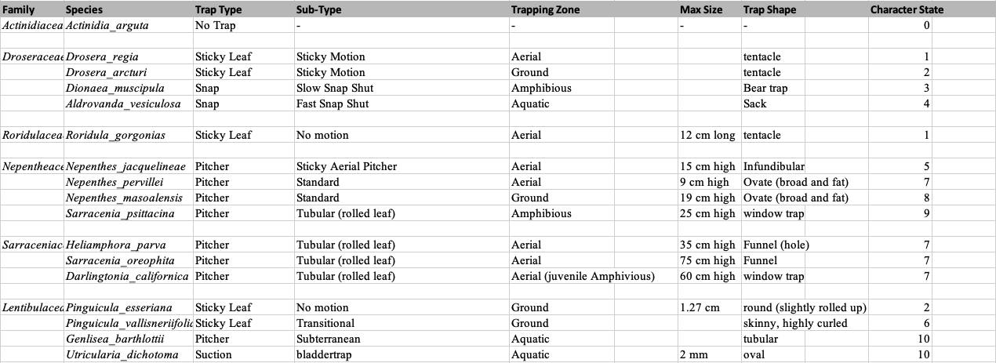

## Transition Rate Matrices

Once the phylogenetic trees have been assembled, we made transition matrices for 18 models after coding each species by its trap type. The Complex Trap Evolution model (labelled “CTE”, see Table 2) represents the pitcher hypothesis for the origin of the *Utricularia* trap as a series of transitions between 11 states. The model involves 12 transition rate parameters and this model was compared to alternative models that postulate other allowed transitions. For example, the simple equal-rates (ER) null model allows all trap types to have equal rates of transition to any other trap type (see Table 3). It represents one version of an “anything is possible” model. The rest of the models are described in Discussion. The transition rate matrix encapsulates the instantaneous rates of transition between ancestral state (left) to descendant (top) states. In the CTE model, the loss of carnivory is indicated by rate 1, representing transitions from any other state to state 1. Rate 2 represents the gain of carnivory postulating that sticky leaf traps were the first form of carnivory to evolve from non-carnivorous ancestors (Darwin, 1875; Craw et al., 1999; Slack, 1988; Juniper et al.,1989). Other rates are as indicated in Table 2.

**Table 2.**Transitionmatrix for the Complex Trap Evolution (CTE) model postulated in Figure 1, which includes the pitcher hypothesis for the origin of the *Utricularia* trap. Each number represents a different free transition rate parameter in the model.

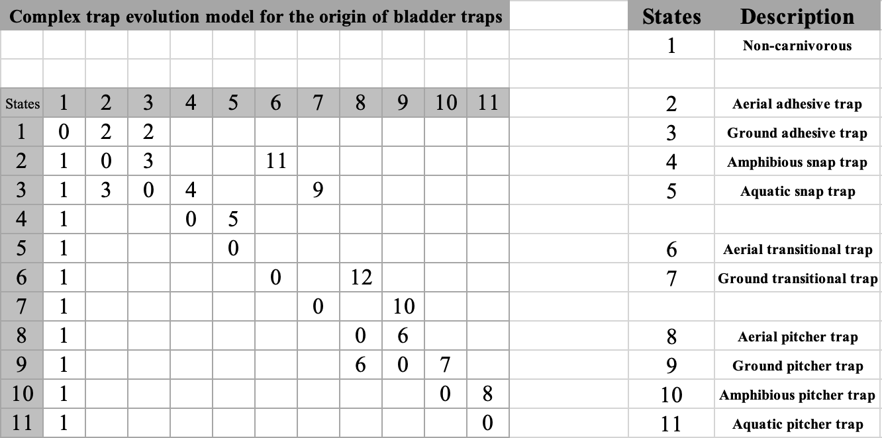

**Table 3.**Score matrix of equal-rates model. All character states have equal rates to transition into one another, represented by 1.

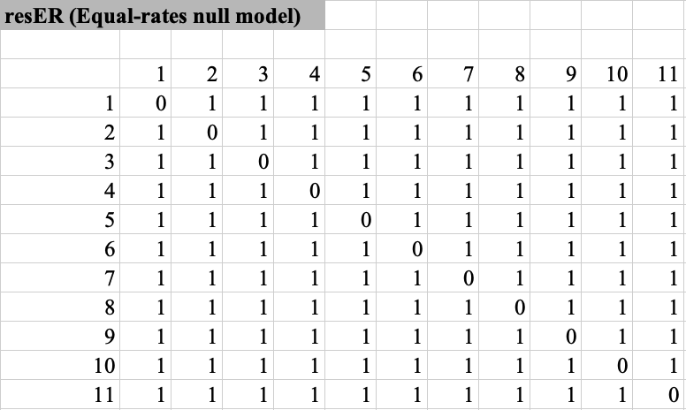

## Evaluating Markov Models for Ancestral Character Estimation

Using the function “fitMk.parallele” in phytools (Revell, 2024), maximum likelihood was used to estimate parameter values that best explain the observed trap type distribution under each model. The maximized log-likelihood (lnL) under each model was used to calculate the Akaike Information Criterion (AIC) for each model, in order to measure the statistical difference in fit between all models (Lanfear et al., 2014). Under a given model, the probability of different ancestral trap types was estimated for ancestral species using ancestral character estimation. To estimate the number and timing of transitions, ancestral character estimation was supplemented with stochastic mapping, using function “simmap” in phytools. Phylogenetic stochastic mapping conducts probabilistic sampling of ancestral states to simulate possible evolutionary histories of trap types across the phylogenetic tree while considering the uncertainty associated with character changes. We ran 100 stochastic simulations to generate a distribution of potential trap-type histories for each ancestral node. To visualise the distribution of ancestral states along key branches within each family, state distribution plots were generated to illustrate changes in character state probabilities over time along these branches to provide a dynamic view of gradual state transitions. For each stochastic map, the cumulative time of transitions within each branch segment was recorded, and a dominant state was assigned to each time interval based on these cumulative timings. This data was organised into a matrix, where each row represented a stochastic map, and each column represented a time interval along the branch, capturing which state was dominant at each time slice along the branch length. To determine the prevalence of each state, the relative frequency of each state within each time interval was calculated across all stochastic maps, generating a probability distribution for each state over time along the branch. This information was summarised in a matrix of state proportions over time, where each cell represented the percentage of a specific state at a given time point along the branch. The final state distribution plot was created by visualising these probabilities as stacked density curves, with each colour-coded area representing the proportion of each state across intervals along the branch

# 

# **Results**

## **Model Selection**

Maximised log-likelihood (LnL) and AIC with AIC weights for each of the 18 models are shown inTable 4**.** The best-fitting model was res7CTEaosb, which supports the pitcher trap hypothesis by allowing transitions from aerial adhesive/pitcher intermediate traps to pitcher traps, while fixing the transition as irreversible. This model was selected based on the lowest AIC value of 707.10235 and the highest AIC weight of nearly 60%. Two similar models (res8CTE and res7CTEgobp) account for the remaining around 40% of the weight, bringing the combined support for the top three models to 99.9%, dominating the credible set of models. The total does not sum to exactly 100% due to the presence of several other models with negligible weights (e.g., <0.0000001%). These results indicate that models allowing the transitional pathways represented in the pitcher hypothesis for the origin of *Utricularia* strongly outperform many other possible models. This applies even for models that allow many more types of transitions between traps, such as the parameter-poor Equal Rates (ER) model, or the parameter-richer All Rates Different (ARD) model.

**Table 4.** AIC summary table for each phylogenetic model. Provided are model log-likelihoods, delta AIC (difference from the best/lowest AIC), relative likelihood (rel_likes), AIC values and weights.

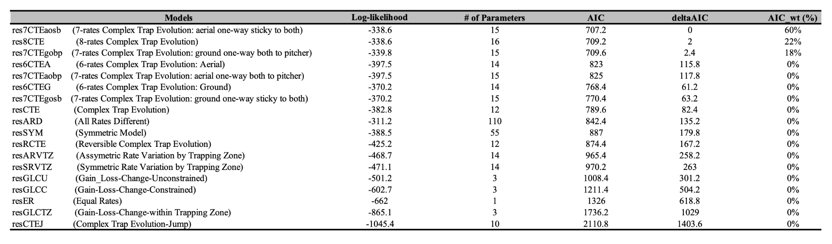

## **Lentibulariaceae**

Phylogenetic stochastic mapping under the best-fitting res7CTEaosb model suggests that the branch below the common ancestor of Lentibulariaceae was non-carnivorous (indicated by the white circle at the branch bottom). However, the most recent common ancestor of crown Lentibulariaceae was likely carnivorous with an "intermediate" trap type having both adhesive and pitcher traits, indicated by grey circles (see Fig. 3). This adhesive/pitcher intermediate trap then diverged into more specialised traps over time (*Utricularia,* *Genlisea*, and *Pinguicula*). State distribution plots visualise the change in ancestral state probabilities along the root branch of Lentibulariaceae, suggesting that a non-carnivorous ancestor (very light grey line, equivalent to white circles) evolved first into a ground adhesive trap (orange line) in the middle of the branch, which becomes most probable around 4 million years along the branch. Around 8 million years along the branch, the ground adhesive/pitcher intermediate trap becomes the most probable state (dark gray). (see Fig. 4). There is only a small probability for an alternative path via an aerial adhesive trap (yellow line).

Many of the early branches in the *Pinguicula* radiation reconstruct as ground adhesive/pitcher intermediate traps, like some living *Pinguicula*. On the branch ancestral to the common ancestor of *Genlisea* + *Utricularia*, for the first third, the adhesive/pitcher intermediate trap is most probable, the ground pitcher trap is most probable for roughly the middle third, and the hypothesised amphibious eeltrap pitcher is the most probable trap type for the final third leading to the last common ancestor node for the two genera (see Fig. 5). Small probability is assigned to an alternative route via an aerial adhesive (orange).

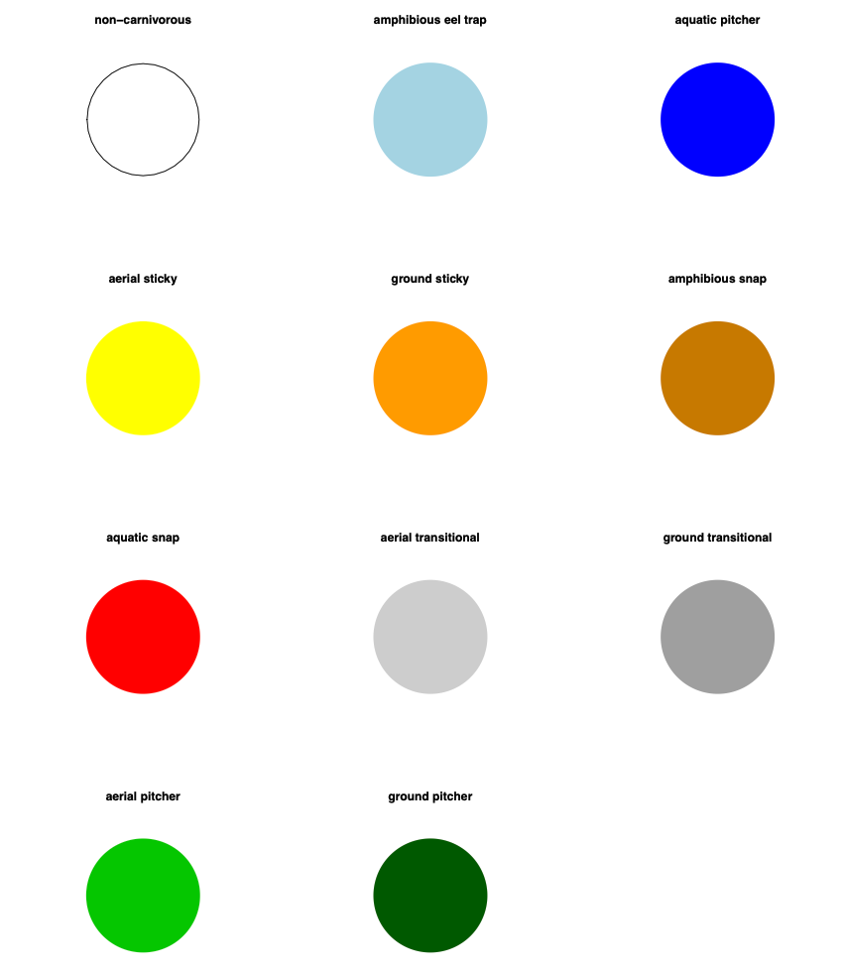

Figure 2: Trap type legend for carnivorous plants, showing the various trapping mechanisms and their associated colours. Each pie chart represents a distinct trap type, with the colour indicating the trap’s classification.

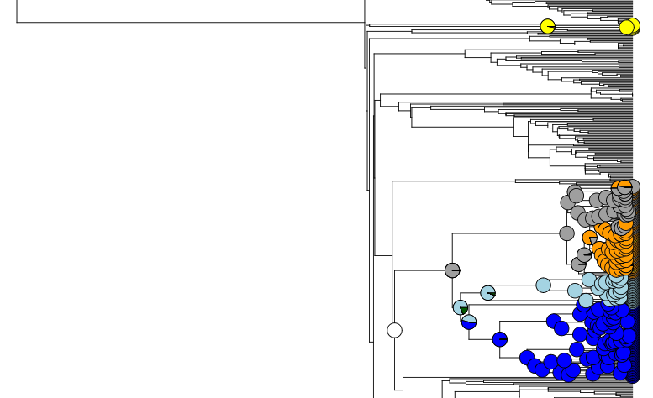

Figure 3. Ancestral trap state estimation for Lentibulariaceae under the best-fitting model (res7CTEaosb) suggests that the branch below the common ancestor of the clade was non-carnivorous (white) and the common ancestor node had an adhesive/pitcher intermediate trap like some living *Pinguicula*. The dark blue clade represents *Utricularia* bladder traps, aquamarine represents *Genlisea* eeltraps, and the clade mixed with orange and grey represents *Pinguicula* (ground adhesive and adhesive/pitcher intermediate traps; Pinguicula also has some aerial adheisve traps, obscured in this plot).

[We could probably come up with a clearer visualiation here actually, e.g. <https://www.frontiersin.org/files/Articles/813336/fevo-10-813336-HTML-r1/image_m/fevo-10-813336-g001.jpg> ; let's do that when we have time.]

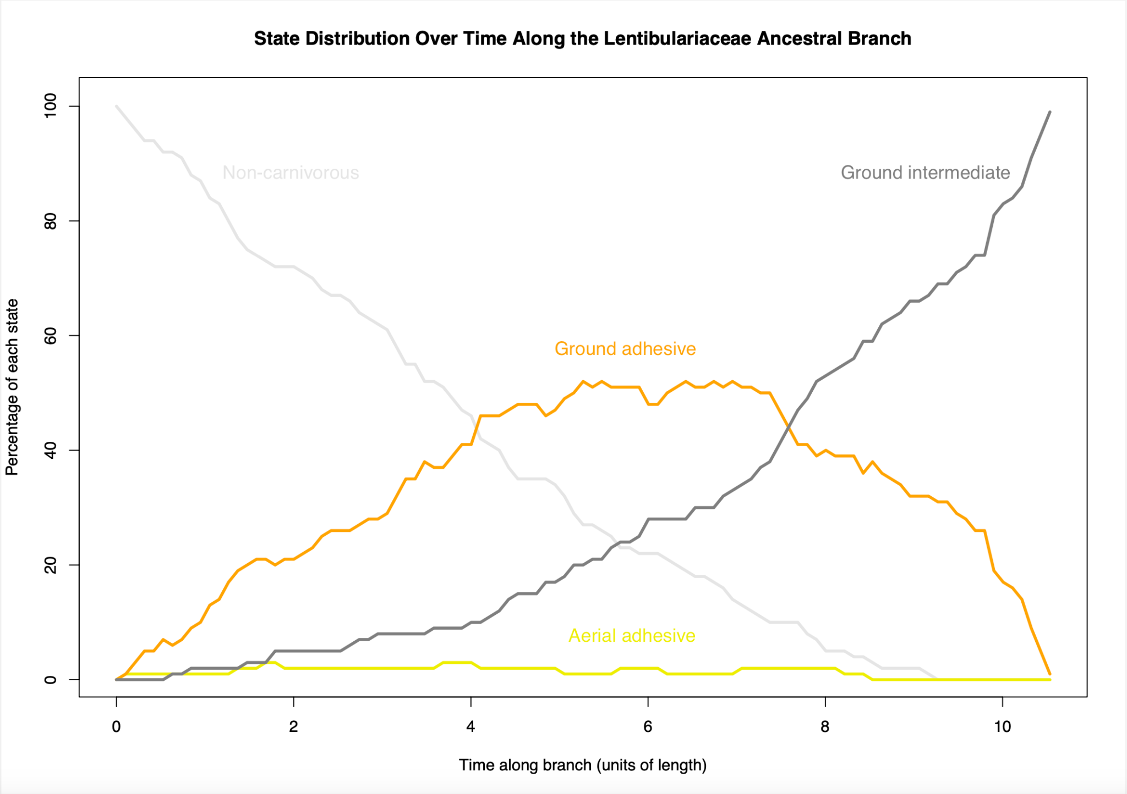

Figure 4. State distribution over time along the Lentibulariaceae ancestral branch, showing the percentage of each state at different points along the branch's length. Colours represent different states: dark grey for the ground adhesive/pitcher intermediate state, orange for the ground adhesive state, yellow for the aerial adhesive state, and white for non-carnivorous state. The plot illustrates changes in the prevalence of each state over time, with the ground adhesive/pitcher intermediate state peaking in frequency before giving way to the ancestral amphibious state with ground pitch characteristics.

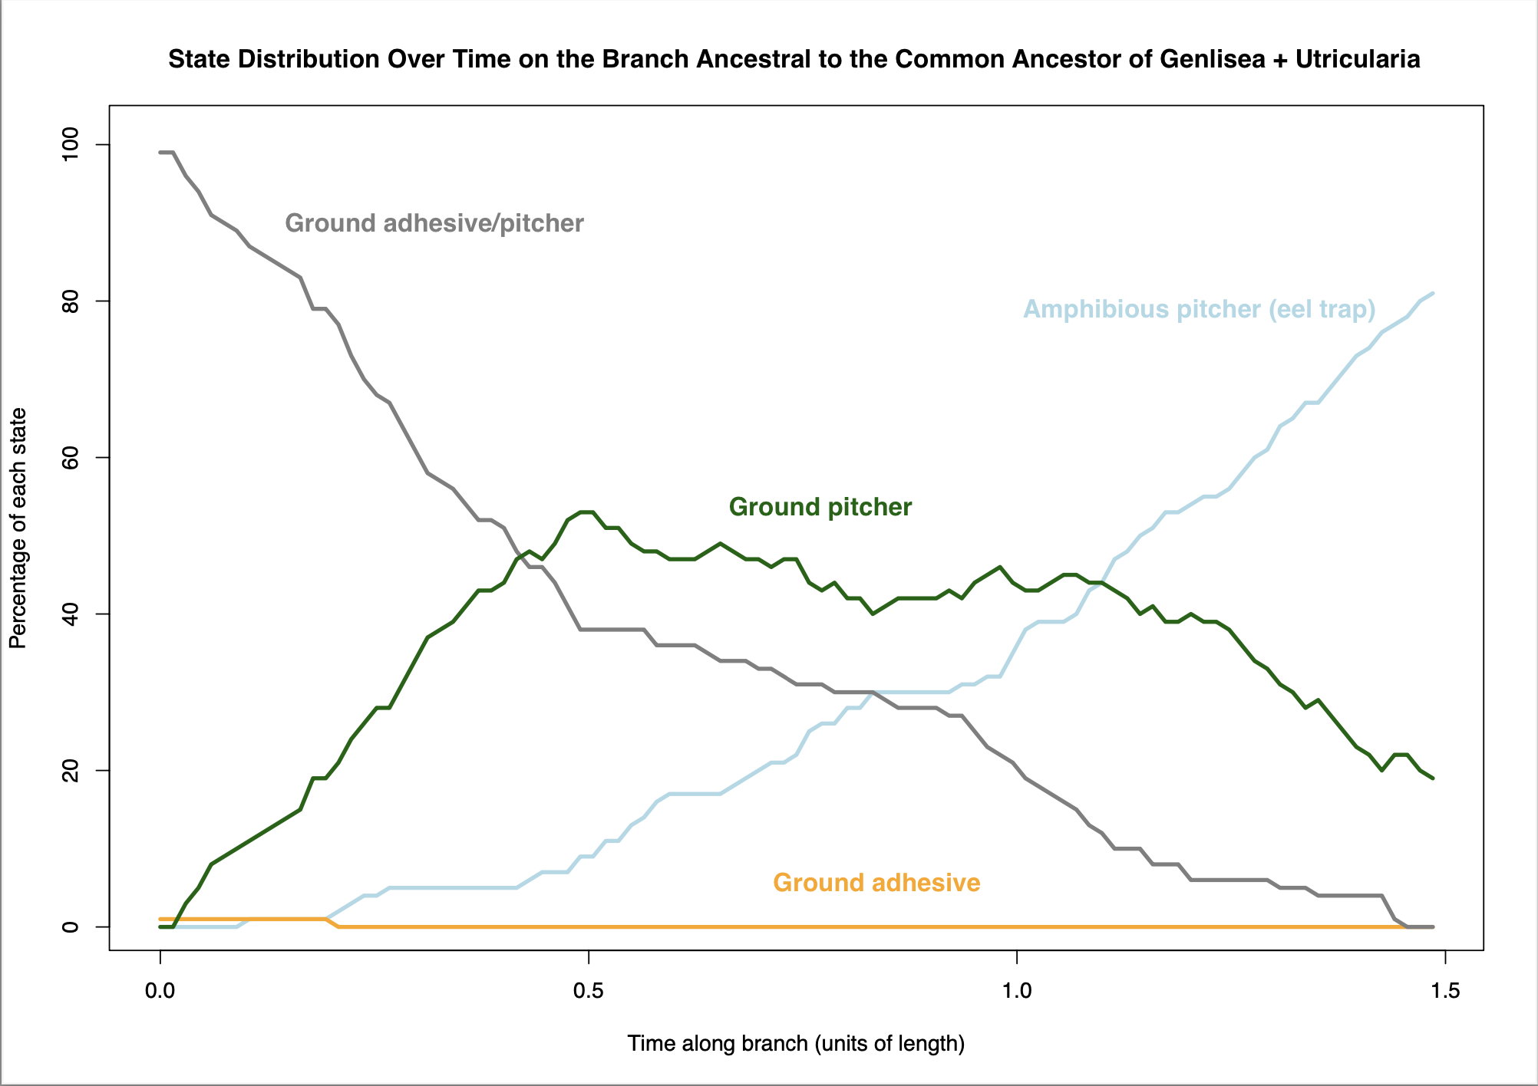

Figure 5. State distribution over time along the *Genlisea +Utricularia* ancestral branch, showing the percentage of each state at different points along the branch's length. Colours represent different states: dark grey for the ground adhesive/pitcher intermediate state, orange for the ground adhesive state, dark green for the ground pitcher state, and aquamarine for amphibious eel trap. The plot illustrates changes in the prevalence of each state over time, with the amphibious eel trap peaking in frequency, with ground pitcher characteristics before giving way to the ancestral aquatic pitcher state with amphibious eel trap characteristics.

## **Sarraceniaceae**

Under the favoured res7CTEaosb model, the branch below the Sarraceniaceae common ancestor appears to be non-carnivorous. The branch up to the common ancestral node shows probability being alloted to several evolutionary pathways, the most probable of which is non-carnivorous (light grey) → aerial adhesive trap (yellow) → aerial adhesive/pitcher intermediate trap (medium grey) → aerial pitcher (light green). However, there is also substantial probability for the branch ending in the aerial adhesive/pitcher intermediate trap state, with subsequent transitions to aerial and then ground pitchers happening later in the history of the clade (see Fig 6). The state distribution plot visualises the gradual evolutionary transition over time along this branch, suggesting that adhesive characters appear alongside aerial adhesive/pitcher intermediate character; however, adhesive characters disappear while pitcher characters appear over time (see Fig 7).

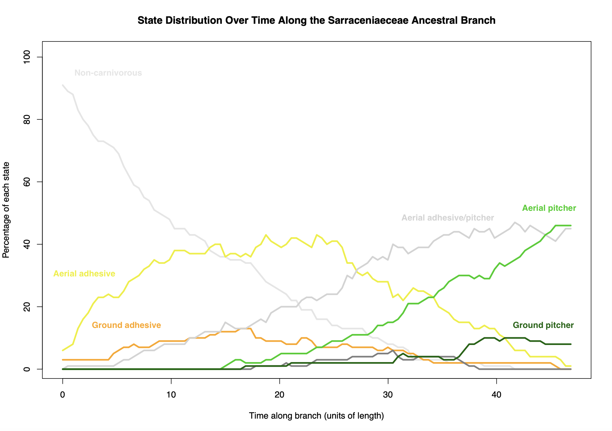

Figure 6. State distribution over time along the *Sarraceniaceae* ancestral branch, showing the percentage of each state at different points along the branch's length. Colours represent different states: dark grey for the ground adhesive/pitcher intermediate trap, orange for the ground adhesive trap, yellow for the aerial adhesive trap, dark green for the ground pitcher trap, light green for the aerial pitcher trap, and medium grey for aerial adhesive/pitcher intermediate state, and light grey for non-carnivorous.

## 

Figure 7. Phylogenetic stochastic mapping in the *Sarraceniaceae* under the best-fitting model (res7CTEaosb) suggests that the bottom of the clade's root branch was non-carnivorous (white) and the last common ancestor was either an aerial pitcher trap (light green) or an aerial/adhesive trap (medium grey). The clade mixed with dark green and light green represents *Sarraceniaceae* aerial and ground pitcher traps, respectively.

## 

## **Nepenthaceaeand Droseraceae**

The res7CTEaosb model estimates the common ancestor of Nepenthaceae and Droseraceae to be an adhesive trap, with approximately equal probability being allocated to ground and aerial forms (see Fig 8). The state distribution plot along this branch also shows this ambiguity, with a roughly equal proportion of stochastic maps favouring transition to these two trap states (see Fig 9).

## **Nepenthaceae**

The common ancestor of *Nepenthaceae* resolves to be an aerial trap with high confidence (see Fig 8). Stochastic mapping on the branch below the common ancestor shows probability for both ground and aerial versions of the adhesive → adhesive/pitcher → pitcher transition series, but with the aerial form of the pitcher (yellow) rapidly coming to dominate probably towards the top of the branch (see Fig 10).

## **Droseraceae**

The while the bottom of the root branch below the common ancestor of Droseraceae appears is ambiguous between a ground and an aerial adhesive trap (see Fig 8), the state distribution plot shows that the that ground adhesive trap comes to dominate the probability as the Droseraceae root node is approached (see Fig 11).

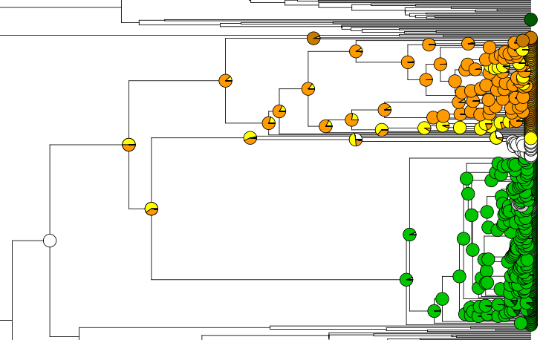

Figure 8.Phylogenetic stochastic mapping in the *Nepenthaceae + Droseraceae* under the best-fitting model (res7CTEaosb) suggests that the lowest common ancestor of the clades was non-carnivorous and the early carnivorous form was a adhesive trap. The green clade represents *Nepenthaceae*, and the clade mixed with yellow and orange represents *Droseraceae*.

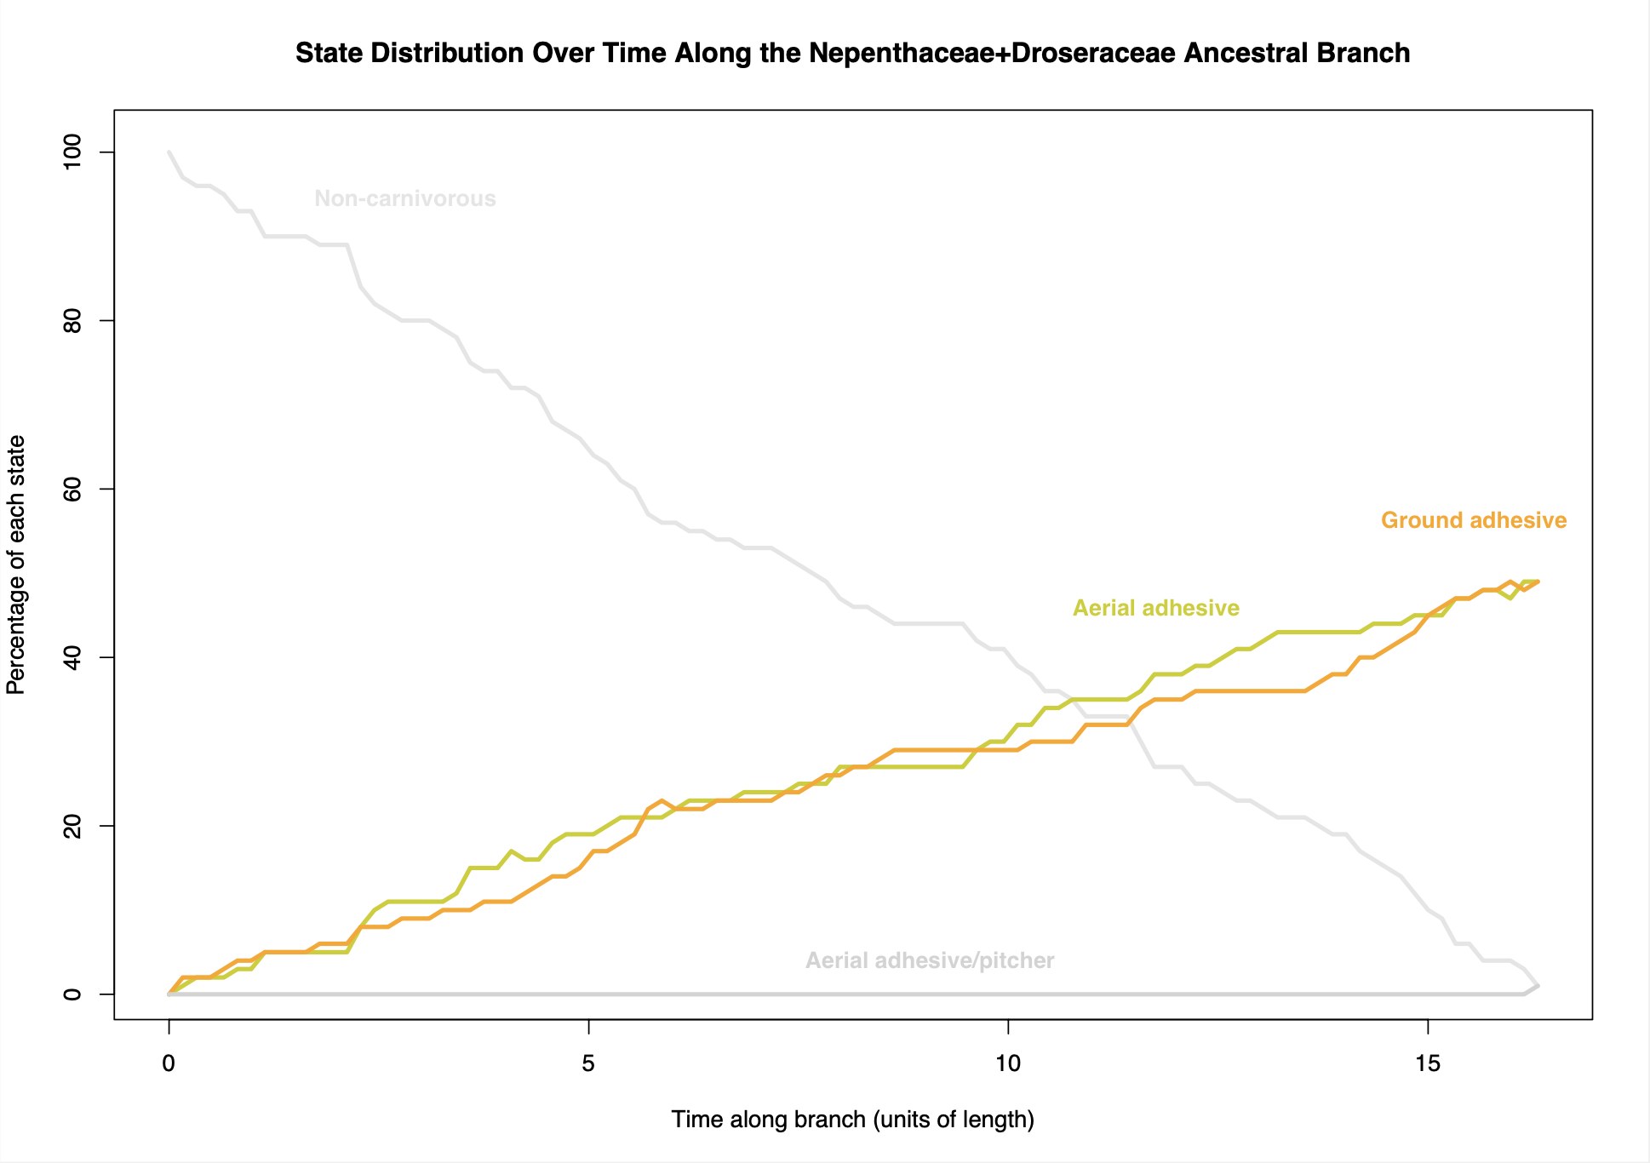

Figure 9. State distribution over time along the *Nepenthaceae + Droseraceae* ancestral branch, showing the percentage of each state at different points along the branch's length. Colours represent different states: light grey for noncarnivorous, medium grey for the aerial adhesive/pitcher state, orange for the ground adhesive state, and yellow for the aerial adhesive state.

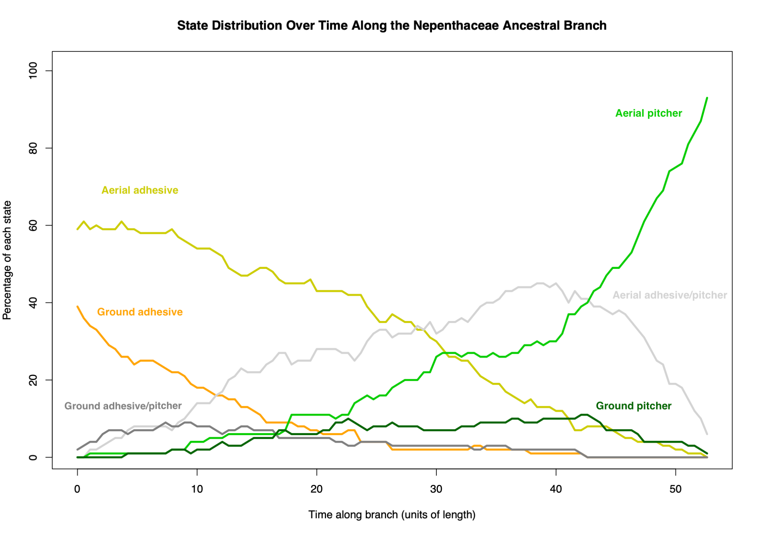

Figure 10. State distribution over time along the Nepenthaceae ancestral branch, showing the percentage of each state at different points along the branch's length. Colours represent different states: dark grey for the ground adhesive/pitcher intermediate state, orange for the ground adhesive state, yellow for the aerial adhesive state, dark green for the ground pitcher state, light green for the aerial pitcher state, and medium grey for aerial adhesive/pitcher intermediate state.

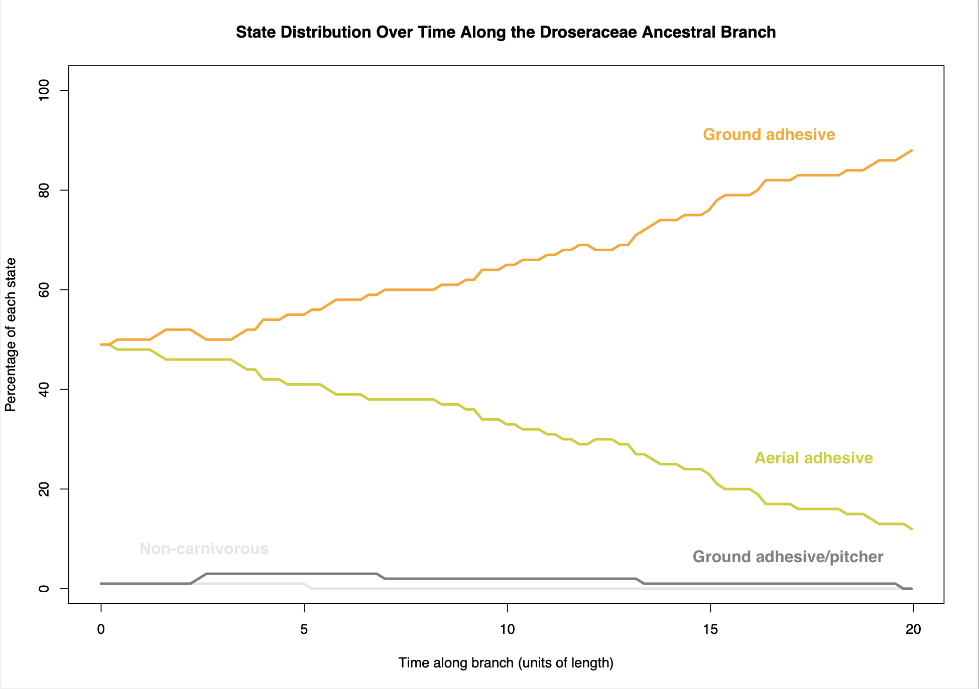

Figure 11: State distribution over time along the Droseraceae ancestral branch, showing the percentage of each state at different points along the branch's length. Colours represent different states: medium grey for aerial adhesive/pitcher intermediate state, orange for the ground adhesive state, yellow for the aerial adhesive state, and dark grey for the ground adhesive/pitcher intermediate state.

# 

# Discussion

Our analyses support the pitcher hypothesis, which posits a gradual evolutionary transition for the origin of *Utricularia* traps from adhesive traps via a pitcher trap intermediate. Models based on this hypothesis were consistently selected among the top eight models. The pitcher hypothesis models (resCTE, resRCTE, res6CTEA, res6CTEG, res7CTEaosb, res7CTEaobp, res7CTEgobp, res7CTEaobp, and res8CTE) explain ancestral carnivorous plants with simple flypaper traps (adhesive traps) evolving through a trap types exhibiting both adhesive and pitcher characteristics, before evolving into pitcher traps, then amphibious eel traps, and subsequently into fully aquatic *Utricularia* bladder traps. These models explore different evolutionary transition scenarios, such as whether certain transitions between traps are reversible. Among the models tested, the best-supported model was res7CTEaosb, which aligns with the pitcher hypothesis. This model does not allow a transition from aerial adhesive/pitcher intermediate trap to the aerial adhesive trap. This suggests that this transition is not necessary to help explain the data. This may indicate an evolutionary constraint suggesting that adhesive/pitcher intermediate traps may evolve into pitcher traits but will not revert to adhesive traps. State distribution plots along the Nepenthaceae and Sarraceniaceae ancestral branches further support this constrained evolutionary pathway (Fig 6 and Fig 10). Initially, an aerial adhesive state (represented by yellow) is present; however, as time progresses, the aerial adhesive/pitcher intermediate state (represented by medium grey) increasingly dominates, eventually overtaking the aerial adhesive state. This transition highlights a directional shift from simple adhesive traps towards more complex intermediate characteristics, which may have facilitated the evolution of pitcher and *Utricularia* traps. The persistence of this pattern across both families reinforces the hypothesis of a gradual and constrained evolutionary trajectory within carnivorous plant lineages.

The consistent selection of pitcher hypothesis models indicates that our models provide better fit to the data (the mega phylogeny and the distribution of observed trap types) than alternative scenarios. The 9th and 10th models selected were resSYM (symmetric model) and resARD (all-rates different model). The Symmetric (SYM) and All Rates Different (ARD) models are standard options in discrete-character evolution software, frequently employed to study the transition dynamics between discrete character states, such as those representing traits in evolutionary biology. The Symmetric model assumes that the rates of change between any two character states are equivalent in both directions, adhering to a symmetric transition matrix. In contrast, the All Rates Different (ARD) model relaxes this constraint, allowing for distinct rates for forward and reverse transitions between character states. This implies that the process of transitioning from one state to another might occur at different rates than the reverse transition. Both models serve as valuable tools for understanding the evolutionary dynamics of discrete traits, with the Symmetric model representing a more constrained scenario and the ARD model offering greater flexibility by acknowledging potential asymmetries in the rates of character state changes. The ARD model scored log-likelihood of -311.2, which is much higher than the AIC-best model res7CTEaosb (-338.6). However, the ARD model, with 110 free parameters describing the rates of all the possible transitions between trap states in all directions, is highly penalised in the AIC calculation, which balances the goodness of fit of a model with the complexity of the model, penalising models with more free parameters (Akaike, 1987). The res7CTEaosb model has only 15 parameters which describe the transitions postulated by the pitcher hypothesis.

Asymmetric and symmetric rate variation by trapping zone models (resARVTZ and resSRVTZ) refer to the implementation of rate transition parameters to the model based on trapping zones (aerial, ground, etc.) rather than trap types (pitcher, sticky, etc.). These models were selected at 12th and 13th based on their AIC. Regarding trapping zone models, resGLCTZ (gain-loss-change within trapping zone model) was selected at 17th. In addition, resGLCU (gain-loss-change unconstrained model) and resGLCC (gain-loss-change constrained model) were selected at 14th and 15th. The gain-loss-change unconstrained model allows for the loss of carnivory, gain of carnivory and the change between any types of trap. In contrast, the constrained model is limited in terms of allowing only for change within the same type of trap. These models are based on types of traps, [what does this mean? transitions only within categories of traps] rather than considering their trapping zones. Together, these models' scores suggest that models that restrict evolutionary transitions between traps to be within-zone or within-trap-category offers an incomplete portrayal of the evolution of carnivorous plant traps. In simpler terms, the poor performance of these models constitutes a test of the hypothesis that carnivorous plant traps cannot transition between zones or between trap types.

These results emphasise that a holistic understanding of carnivorous plant trap evolution necessitates the consideration of both trapping zones and trap types. Moreover, models such as resARVTZ and resSRVTZ, which introduce rate transition parameters based on trapping zones over those exclusively centred on trap types (e.g., pitcher hypothesis models), highlight the significance of ecological adaptations associated with different trapping zones. This underscores the inadequacy of a unidimensional approach and supports a multifaceted framework that encapsulates the varied dimensions of carnivorous plant trap evolution. The equal-rate model (resER) refers to the model that all character states have equal rates to transition into any character states, which is ranked 16th under model selection. Finally, the worst-performing model was resCTEJ (Complex Trap Evolution-Jump model), which refers to a simplified pitcher hypothesis model where gradual evolutionary transitions (e.g. adhesive traps evolve to intermediate traps, and then into pitcher traps) are disallowed, but sudden jumps are allowed (e.g. adhesive traps evolve to pitcher traps, without transitioning through intermediate traps). The poor performance of this model suggests the importance of considering intermediate adhesive/pitcher traps in understanding carnivorous plant trap evolution.

# Limitations and Future Directions

The study on the evolutionary dynamics of carnivorous plant traps, particularly focusing on *Utricularia*, has its inherent limitations that should be considered. One significant constraint pertains to the data utilised in the analysis. The study's scope and depth may be contingent upon the availability and completeness of existing data on *Utricularia* and other carnivorous plant lineages. Incomplete or limited datasets could potentially introduce biases or gaps in our understanding of trap evolution. Addressing this limitation would require more comprehensive DNA sequencing of carnivorous plants, particularly in the Lentibulariaceae. Another set of limitations arises from the modelling assumptions inherent in the study. To make the study feasible, trap evolution was discretized into 11 trap types. This is useful for testing hypotheses about the major stages by which traps evolve, but alternative modelling approaches could provide a more nuanced and comprehensive understanding of the evolutionary dynamics under consideration. For example, future studies could integrate trap size (a continuous trait), atomise traps into a series of specific trap characters (trichomes, mucilage, enzymes, etc.), or incorporate complexities such as trap dimorphism where an individual has multiple trap types adapted to different trapping zones or different seasons.

Another limitation is that while the research delves into trap evolution, the intricate interplay between ecological factors and the evolutionary trajectories of carnivorous plants may not be fully captured. This limitation prompts future research avenues to explore the specific ecological triggers, nutrient dynamics, and interactions with other species that shape the evolution of carnivorous plant traps.

A final limitation is the phylogenetic dating available for this study. To construct a dated supertree, we combined dated phylogenies for clades where these were available, and where they were not available, we employed the program r8s to put relative dates on non-dated trees, and then spliced these trees into the dated supertree of vascular plants. While much simpler than attempting a massive effort to re-date all of the carnivorous plant clades from scratch, this approach introduces substantial uncertainty into the temporal aspects of trap evolution. In particular, the very short time branch between the common ancestor of *Genlisea*+*Utricularia*, and the common ancestor of the Lentibulariaceae, could easily be an artefact of this splicing approach. The short branch is surprising given that our favoured model puts a major transition (intermediate trap → ground pitcher → amphibious pitcher) into under 2 million years, but the probabilistic methods used here will fit the necessary transitions into branches of any length. Although this comes with a cost in likelihood scores (fitting many transitions onto a short branch is less probable than fitting them to a longer branch), in this study, all the models were run on the same tree, so all models were similarly penalised. A future study could improve on ours by attempting to comprehensively re-date the Lentibulariaceae and its sister groups; this is however likely to be challenging due to lack of fossil calibration points.

Integrating genomic analysis into future studies represents another future direction. Comparative genomics might reveal key genes or developmental networks associated with different trap types and their evolution. If the pitcher hypothesis is correct, we might even anticipate future experimental support. Much as experiments in developmental biology have produced chickens with teeth and tails (representing characteristics in ancestral dinosaurs), and mice with shortened tails (representing the developmental changes that removed tails from ancestral apes), it is possible that modifying trap development in Genlisea or Utricularia could produce traps that more closely resemble our hypothesised ancestral pitchers, for example by having open entrances, entrances facing upwards (as in pitfall traps), and/or traps that are above the surface of the ground or water, rather than underground or underwater.

[We could mention biogeography and fossils as well, but probably we've got too much text even on this edited version]

# 

# Acknowledgements

I would like to express my sincere gratitude to Dr. Nick Matzke, whose expertise in phylogeny and biogeography and unwavering support made this research possible. His guidance, from introducing the research to providing assistance in bioinformatics and computational analysis, has been invaluable. I appreciate his patience in helping me navigate R studio coding and answering my numerous questions. I am truly grateful for the opportunity he gave me to delve into my passion for evolution, phylogeny, and biogeography.

# 

# 

# **Appendices**

# 

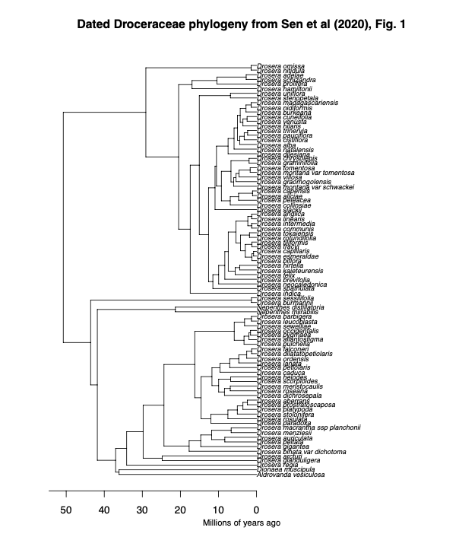

**Appendix 1:** Digitised *Droceraceae* phylogenetic tree from Sen et al. (2020), Fig. 1. The tree was manually digitised using the WebPlotDigitizer tool, allowing quantitative data extraction from the original graphical representation. Calibration of axes was performed based on estimated time (million years ago), ensuring accurate scaling. Data points corresponding to tips, nodes, and corners positions were digitised.

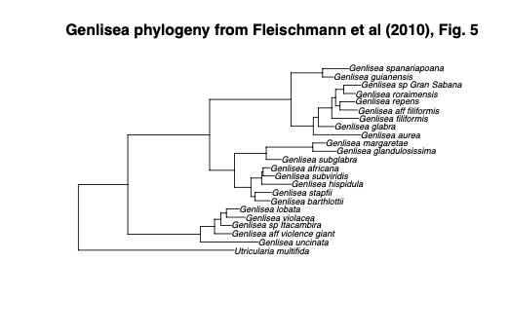

**Appendix 2:** Digitised *Genlisea* phylogenetic tree from Fleischmann et al. (2010), Fig. 5. The tree was manually digitised using the WebPlotDigitizer tool, allowing quantitative data extraction from the original graphical representation. Calibration of axes was performed based on branch length (0.03), ensuring accurate scaling. Data points corresponding to tips, nodes, and corners positions were digitised.

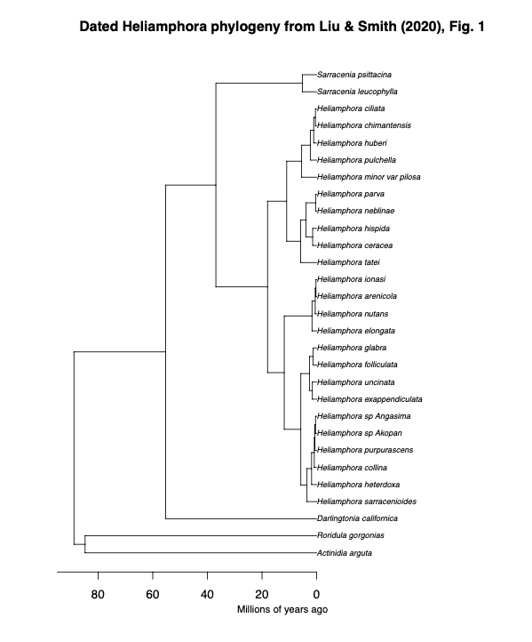

**Appendix 3:** Digitised *Heliamphora* phylogenetic tree from Liu and Smith (2020), Fig. 1. The tree was manually digitised using the WebPlotDigitizer tool, allowing quantitative data extraction from the original graphical representation. Calibration of axes was performed based on estimated time (million years ago), ensuring accurate scaling. Data points corresponding to tips, nodes, and corners positions were digitised.

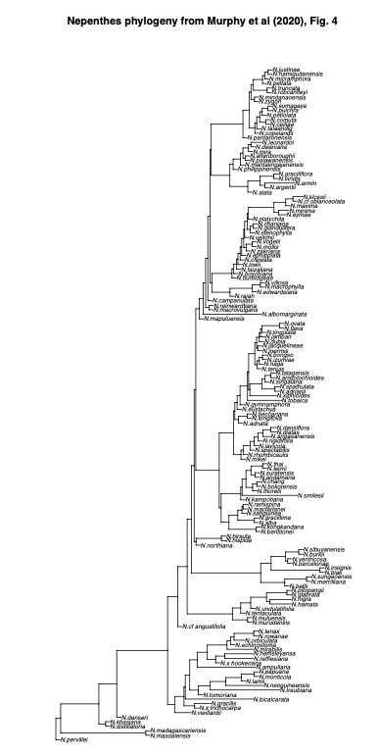

**Appendix 4:** Digitised *Nepenthes* phylogenetic tree from Murphy et al. (2020), Fig. 4. The tree was manually digitised using the WebPlotDigitizer tool, allowing quantitative data extraction from the original graphical representation. Calibration of axes was performed based on branch length (0.5), ensuring accurate scaling. Data points corresponding to tips, nodes, and corners positions were digitised.

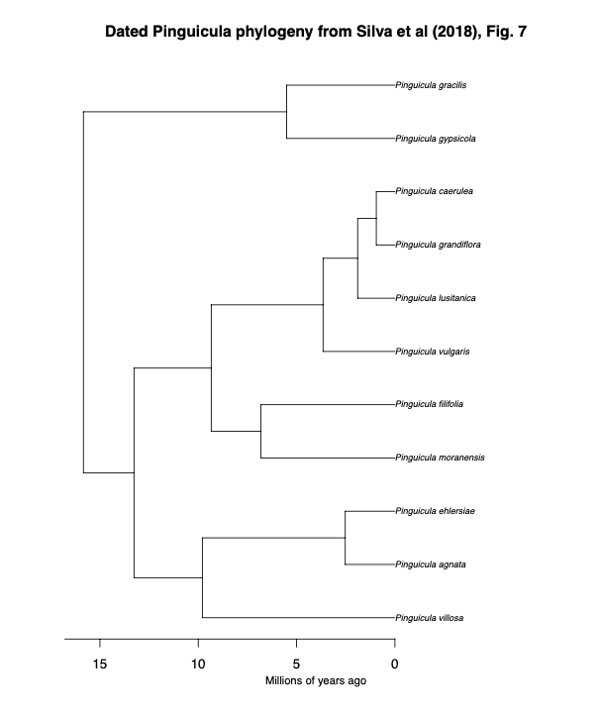

**Appendix 5:** Digitised *Pinguicula* phylogenetic tree from Shimai et al. (2021), S1 Fig. 1. The tree was manually digitised using the WebPlotDigitizer tool, allowing quantitative data extraction from the original graphical representation. The tree was not available for estimated and branch length; thus used r8s programme to ensure accurate scaling when assembling trees. Data points corresponding to tips, nodes, and corners positions were digitised.

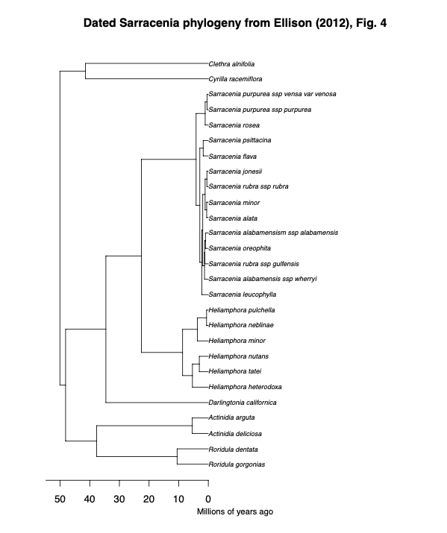

**Appendix 6:** Digitised *Sarracenia* phylogenetic tree from Ellison et al. (2012), Fig. 4. The tree was manually digitised using the WebPlotDigitizer tool, allowing quantitative data extraction from the original graphical representation. Calibration of axes was performed based on estimated time (million years ago), ensuring accurate scaling. Data points corresponding to tips, nodes, and corners positions were digitised.

# References

Adamec, L. (2018). Biological flora of Central Europe: Aldrovanda vesiculosa L. *Perspectives in Plant Ecology, Evolution and Systematics*, *35*, 8–21.<https://doi.org/10.1016/j.ppees.2018.10.001>

Adlassnig, W., Peroutka, M., & Lendl, T. (2011). Traps of carnivorous pitcher plants as a habitat: Composition of the fluid, biodiversity and mutualistic activities. *Annals of Botany*, *107*(2), 181–194.

Akaike, H. (1987). Factor analysis and AIC. *Psychometrika*, *52*(3), 317–332.<https://doi.org/10.1007/BF02294359>

Albert, V. A., Jobson, R. W., Michael, T. P., & Taylor, D. J. (2010). The carnivorous bladderwort (Utricularia, Lentibulariaceae): A system inflates. *Journal of Experimental Botany*, *61*(1), 5–9.<https://doi.org/10.1093/jxb/erp349>

Barthlott, W., & Ashdown, M. (2007). *The curious world of carnivorous plants : a comprehensive guide to their biology and cultivation* (English language ed.). Timber Press.

Benzinq D. H. (1987). The origin and rarity of botanical carnivory. *Trends in ecology & evolution*, *2*(12), 364–369. https://doi.org/10.1016/0169-5347(87)90137-6

Böhm, J., Scherzer, S., Krol, E., Kreuzer, I., von Meyer, K., Lorey, C., Mueller, T. D., Shabala, L., Monte, I., Solano, R., Al-Rasheid, K. A. S., Rennenberg, H., Shabala, S., Neher, E., & Hedrich, R. (2016). The Venus Flytrap Dionaea muscipula Counts Prey-Induced Action Potentials to Induce Sodium Uptake. *Current Biology*, *26*(3), 286–295.<https://doi.org/10.1016/j.cub.2015.11.057>

Carmesin, C. F., Fleischmann, A. S., Klepsch, M. M., Westermeier, A. S., Speck, T., Jansen, S., & Poppinga, S. (2021). Structural gradients and anisotropic hydraulic conductivity in the enigmatic eel traps of carnivorous corkscrew plants (Genlisea spp.). *American Journal of Botany*, *108*(12), 2356–2370.<https://doi.org/10.1002/ajb2.1779>

Cheek, M., 1987. Evolution in Lentibulariaceae: a criticism of Snyder. Carnivorous Plant

Newsletter. 16 (4), 103.

Clarke, C.M. 2001. [*Nepenthes of Sumatra and Peninsular Malaysia*](https://en.wikipedia.org/wiki/Nepenthes_of_Sumatra_and_Peninsular_Malaysia). Natural History Publications (Borneo), Kota Kinabalu.

Cook, Steve R. (2001). When plants kill, accessed online: October 10, 2001. URL: <https://web.archive.org/web/20040207035715/http://www.steve.gb.com/vegetable_empire/murder.html>

Craw, R. C., Grehan, J. R., & Heads, M. J. (1999). *Panbiogeography: Tracking the History of Life*. Oxford University Press, Incorporated.<http://ebookcentral.proquest.com/lib/auckland/detail.action?docID=430300>

D'Amato, P., 1998. The savage garden : cultivating carnivorous plants. Ten Speed Press,

Berkeley, Calif.

Darwin, C. (1875a). *Insectivorous Plants*. D. Appleton, New York.

Darwin, C. (1875b), “Letter no. 10088,” Darwin Correspondence Project. accessed on 6 June 2023. <https://www.darwinproject.ac.uk/letter/?docId=letters/DCP-LETT-10088.xml>

Di Giusto, B., Bessière, J.-M., Guéroult, M., Lim, L. B. L., Marshall, D. J., Hossaert-Mckey, M., & Gaume, L. (2010). Flower-scent mimicry masks a deadly trap in the carnivorous plant Nepenthes rafflesiana. *Journal of Ecology*, *98*(4), 845–856.

Ellison, A. M., Butler, E. D., Hicks, E. J., Naczi, R. F. C., Calie, P. J., Bell, C. D., & Davis, C. C. (2012). Phylogeny and Biogeography of the Carnivorous Plant Family Sarraceniaceae. *PLoS ONE*, *7*(6), e39291.<https://doi.org/10.1371/journal.pone.0039291>

Ellison, A. M., & Gotelli, N. J. (2001). Evolutionary ecology of carnivorous plants. *Trends in Ecology & Evolution*, *16*(11), 623–629.<https://doi.org/10.1016/S0169-5347(01)02269-8>

Fleischmann, A. (2012a). *Monograph of the Genus Genlisea*. Redfern Natural History Productions.<https://books.google.co.nz/books?id=UNknYAAACAAJ>

Fleischmann, A. (2012b). The new Utricularia species described since Peter Taylor’s monograph. Carnivorous Plant Newsletter 41: 67-76.

Fleischmann, A., Schäferhoff, B., Heubl, G., Rivadavia, F., Barthlott, W., & Müller, K. F. (2010). Phylogenetics and character evolution in the carnivorous plant genus Genlisea A. St.-Hil. (Lentibulariaceae). *Molecular Phylogenetics and Evolution*, *56*(2), 768–783.<https://doi.org/10.1016/j.ympev.2010.03.009>

Fleischmann, A., Schlauer, J., Smith, S. A., & Givnish, T. J. (2018). *Evolution of carnivory in angiosperms* (Vol. 1). Oxford University Press.<https://doi.org/10.1093/oso/9780198779841.003.0003>

Forterre, Y., Skotheim, J. M., Dumais, J., & Mahadevan, L. (2005). How the Venus flytrap snaps. *Nature*, *433*(7024), 421–425.<https://doi.org/10.1038/nature03185>

Gaascht, F., Dicato, M., & Diederich, M. (2013). Venus Flytrap (Dionaea muscipula Solander ex Ellis) Contains Powerful Compounds that Prevent and Cure Cancer. *Frontiers in Oncology*, *3*, 202.<https://doi.org/10.3389/fonc.2013.00202>

Gould, S. J. (1980). Is a New and General Theory of Evolution Emerging? *Paleobiology*, *6*(1), 119–130.

Gould, S. J., & Eldredge, N. (1977). Punctuated Equilibria: The Tempo and Mode of Evolution Reconsidered. *Paleobiology*, *3*(2), 115–151.

Hotti, H., Gopalacharyulu, P., Seppänen-Laakso, T., & Rischer, H. (2017). Metabolite profiling of the carnivorous pitcher plants Darlingtonia and Sarracenia. *PLoS One*, *12*(2), e0171078.<https://doi.org/10.1371/journal.pone.0171078>

Jin, Y., & Qian, H. (2019). V.PhyloMaker: An R package that can generate very large phylogenies for vascular plants. *Ecography*, *42*(8), 1353–1359.<https://doi.org/10.1111/ecog.04434>

Jobson, R. W., Baleeiro, P. C., & Reut, M. S. (2017). Molecular phylogeny of subgenus Polypompholyx (Utricularia; Lentibulariaceae) based on three plastid markers: Diversification and proposal for a new section. *Australian Systematic Botany*, *30*(3), 259–278.<https://doi.org/10.1071/SB17003>

Joyeux, M. (2013). Elastic models of the fast traps of carnivorous *Dionaea* and *Aldrovanda*. *Physical Review E*, *88*(3).<https://doi.org/10.1103/PhysRevE.88.034701>

Juniper, B. E., 1986. The path to plant carnivory, in: Juniper, B. E. and Southwood, T. R.

E. (Eds.), Insects and the Plant Surface, Edward Arnold, London, pp. 195-218.

Juniper, B. E., Robins, R. J. and Joel, D. M., 1989. The Carnivorous Plants. Academic

Press, London ; San Diego.

Körner, C. (2016). Plant adaptation to cold climates. *F1000Research*, *5*.<https://doi.org/10.12688/f1000research.9107.1>

Kosakovsky Pond, S. L., Murrell, B., Fourment, M., Frost, S. D. W., Delport, W., & Scheffler, K. (2011). A Random Effects Branch-Site Model for Detecting Episodic Diversifying Selection. *Molecular Biology and Evolution*, *28*(11), 3033–3043.<https://doi.org/10.1093/molbev/msr125>

Krupa, J. J., Hopper, K. R., Gruber, S. B., Schmidt, J. M., & Harwood, J. D. (2020). Plant–animal interactions between carnivorous plants, sheet‐web spiders, and ground‐running spiders as guild predators in a wet meadow community. *Ecology and Evolution*, *10*(11), 4762–4772.<https://doi.org/10.1002/ece3.6230>

Kubitzki, K. (2003). Droseraceae. In K. Kubitzki & C. Bayer (Eds.), *Flowering Plants · Dicotyledons: Malvales, Capparales and Non-betalain Caryophyllales* (pp. 198–202). Springer.<https://doi.org/10.1007/978-3-662-07255-4_21>

Laakkonen, L., Jobson, R. W., & Albert, V. A. (2006). A New Model for the Evolution of Carnivory in the Bladderwort Plant (Utricularia): Adaptive Changes in Cytochrome c Oxidase (COX) Provide Respiratory Power. *Plant Biology*, *8*(6), 758–764.<https://doi.org/10.1055/s-2006-924459>

Lanfear, R., Calcott, B., Kainer, D., Mayer, C., & Stamatakis, A. (2014). Selecting optimal partitioning schemes for phylogenomic datasets. *BMC Evolutionary Biology*, *14*, 82.<https://doi.org/10.1186/1471-2148-14-82>

Lee, L., Zhang, Y., Ozar, B., Sensen, C. W., & Schriemer, D. C. (2016). Carnivorous Nutrition in Pitcher Plants ( *Nepenthes* spp.) via an Unusual Complement of Endogenous Enzymes. *Journal of Proteome Research*, *15*(9), 3108–3117.<https://doi.org/10.1021/acs.jproteome.6b00224>

Liu, S., & Smith, S. D. (2021). Phylogeny and biogeography of South American marsh pitcher plant genus Heliamphora (Sarraceniaceae) endemic to the Guiana Highlands. *Molecular Phylogenetics and Evolution*, *154*, 106961.<https://doi.org/10.1016/j.ympev.2020.106961>

Lloyd, F. E., & Lloyd, F. E. (1942). *The carnivorous plants, by Francis Ernest Lloyd* (pp. 1–376). Chronica Botanica Company.<https://doi.org/10.5962/bhl.title.5965>

McPherson, S.R. 2009. [*Pitcher Plants of the Old World*](https://en.wikipedia.org/wiki/Pitcher_Plants_of_the_Old_World). 2 volumes. Redfern Natural History Productions, Poole.

Matzke, N. (2005). "Evolution of the *Utricularia* Bladder Trap: A Short Summary." *Bay Area Carnivorous Plant Society Newsletter*, Spring 2005. <https://web.archive.org/web/20120711211927/http://www.bacps.org/2005Spring.html#utrictrap>

Matzke N (2013). BioGeoBEARS: BioGeography with Bayesian (and Likelihood)

Evolutionary Analysis in R Scripts_. University of

California, Berkeley, Berkeley, CA.

Mazrimas, J. A. and Juniper, B. E., 1987. The path to plant carnivory, by Dr. B.E.

Juniper, summarized by J.A. Mazrimas. Carnivorous Plant Newsletter. 16 (2), 54-57.

Mithöfer, A. (2021). A spotlight on prey-induced metabolite dynamics in sundew. A commentary on: ‘Metabolomic analysis reveals reliance on secondary plant metabolites to facilitate carnivory in the Cape sundew, Drosera capensis.’ *Annals of Botany*, *128*(3), v–vi.<https://doi.org/10.1093/aob/mcab093>

Mithöfer, A. (2022). Carnivorous plants and their biotic interactions. *Journal of Plant Interactions*, *17*(1), 333–343.<https://doi.org/10.1080/17429145.2022.2038710>

Moldowan, P. D., Smith, M. A., Baldwin, T., Bartley, T., Rollinson, N., & Wynen, H. (2019). Nature’s pitfall trap: Salamanders as rich prey for carnivorous plants in a nutrient-poor northern bog ecosystem. *Ecology*, *100*(10), 1–4.

Moran, J. A. (1996). Pitcher Dimorphism, Prey Composition and the Mechanisms of Prey Attraction in the Pitcher Plant Nepenthes Rafflesiana in Borneo. *Journal of Ecology*, *84*(4), 515–525.<https://doi.org/10.2307/2261474>

Murphy, B., Forest, F., Barraclough, T., Rosindell, J., Bellot, S., Cowan, R., Golos, M., Jebb, M., & Cheek, M. (2020). A phylogenomic analysis of Nepenthes (Nepenthaceae). *Molecular Phylogenetics and Evolution*, *144*, 106668.<https://doi.org/10.1016/j.ympev.2019.106668>

Newell, S. J., & Nastase, A. J. (1998). Efficiency of Insect Capture by Sarracenia purpurea (Sarraceniaceae), the Northern Pitcher Plant. *American Journal of Botany*, *85*(1), 88–91.<https://doi.org/10.2307/2446558>

Paradis, E., & Schliep, K. (2019). ape 5.0: An environment for modern phylogenetics and evolutionary analyses in R. *Bioinformatics*, *35*(3), 526–528.<https://doi.org/10.1093/bioinformatics/bty633>

Płachno, B. J.; Silva, S. R., Świątek, P., Dixon, K. W., Lustofin, K., Seber, G. C., Miranda, V. F. O. (2020). Structural Features of Carnivorous Plant (Genlisea, Utricularia) Tubers as Abiotic Stress Resistance Organs. *International Journal of Molecular Sciences*, *21*(14), 5143.<https://doi.org/10.3390/ijms21145143>

Poppinga, S., Masselter, T., & Speck, T. (2013). Faster than their prey: New insights into the rapid movements of active carnivorous plants traps. *BioEssays*, *35*(7), 649–657.<https://doi.org/10.1002/bies.201200175>

Poppinga, S., Tim, K., Amélie, M., Speck, O., & Speck, T. (2016). Comparative kinematical analyses of Venus flytrap (Dionaea muscipula) snap traps. *Beilstein Journal of Nanotechnology*, *7*, 664–674.<https://doi.org/10.3762/bjnano.7.59>

Price, M. N., Dehal, P. S., & Arkin, A. P. (2010). FastTree 2 – Approximately Maximum-Likelihood Trees for Large Alignments. *PLoS ONE*, *5*(3), e9490.<https://doi.org/10.1371/journal.pone.0009490>

Revell, L. J. (2024). phytools 2.0: An updated R ecosystem for phylogenetic comparative methods (and other things). *PeerJ*.<https://doi.org/10.7717/peerj.16505>

Rice, B. (2007). Carnivorous plants with hybrid trapping strategies. *Carnivorous Plant Newsletter*, *36*(1), 23–27.<https://doi.org/10.55360/cpn361.br152>

Roccia, Aymeric & Gluch, Oliver & Lampard, Stan & Robinson, Alastair & Fleischmann, Andreas & McPherson, Stewart & Legendre, Laurent & Partrat, Eric & Temple, Paul. (2016). Pinguicula of the Temperate North. Redfern Natural History Productions, Poole.

Sanderson, M. J. (n.d.). *R8s, version 1.70 User’s Manual*.

Scorza, L. C. T., & Dornelas, M. C. (2011). Plants on the move: Towards common mechanisms governing mechanically-induced plant movements. *Plant Signaling & Behavior*, *6*(12), 1979.<https://doi.org/10.4161/psb.6.12.18192>

Sen, S., Tiwari, N., & Ganesan, R. (2020). *Eocene origin, Miocene diversification and intercontinental dispersal of the genus Drosera (Droseraceae)* (p. 2020.08.06.240234). bioRxiv.<https://doi.org/10.1101/2020.08.06.240234>

Shimai, H., Setoguchi, H., Roberts, D. L., & Sun, M. (2021). Biogeographical patterns and speciation of the genus Pinguicula (Lentibulariaceae) inferred by phylogenetic analyses. *PLOS ONE*, *16*(6), e0252581.<https://doi.org/10.1371/journal.pone.0252581>

Schnell, D.E. 2002, Carnivorous plants of the United States and Canada. (2nd Edition)

Timber Press, Portland, 468p

Silva, S. R., Diaz, Y. C. A., Penha, H. A., Pinheiro, D. G., Fernandes, C. C., Miranda, V. F. O., Michael, T. P., & Varani, A. M. (2016). The Chloroplast Genome of Utricularia reniformis Sheds Light on the Evolution of the ndh Gene Complex of Terrestrial Carnivorous Plants from the Lentibulariaceae Family. *PLOS ONE*, *11*(10), e0165176.<https://doi.org/10.1371/journal.pone.0165176>

Singh, K., Reyes, R. C., Campa, G., Jr, Brown, M. D., Hidalgo, F., Berg, O., Müller, U. K., & Link to external site, this link will open in a new window. (2020). Suction Flows Generated by the Carnivorous Bladderwort Utricularia—Comparing Experiments with Mechanical and Mathematical Models. *Fluids*, *5*(1), 33.<https://doi.org/10.3390/fluids5010033>

Slack, A. and Gate, J., 1988. Carnivorous plants. MIT Press, Cambridge, Mass.

Srivastava, A., Rogers, W. L., Breton, C. M., Cai, L., & Malmberg, R. L. (2011).

Transcriptome Analysis of Sarracenia, an Insectivorous Plant. *DNA Research: An*

*International Journal for Rapid Publication of Reports on Genes and Genomes*,

*18*(4), 253–261.<https://doi.org/10.1093/dnares/dsr014>

Snyder, I., 1987. Carnivorous plant evolution: family Lentibulariaceae. Carnivorous

Plant Newsletter. 16 (1), 17-19.

Tagawa, K., & Watanabe, M. (2021). Group foraging in carnivorous plants: Carnivorous plant Drosera makinoi (Droseraceae) is more effective at trapping larger prey in large groups. *Plant Species Biology*, *36*(1), 114–118.<https://doi.org/10.1111/1442-1984.12290>

Tagawa, K., Watanabe, M., & Yahara, T. (2018). Pollinator trapping in selfing carnivorous plants, Drosera makinoi and D. toyoakensis (Droseraceae). *Ecological Research*, *33*(2), 487–494.<https://doi.org/10.1007/s11284-018-1572-6>

Taylor, P., 1989. The Genus Utricularia - a taxonomic monograph. Royal Botanic

Gardens, Kew, London.

Voigt, D., Gorb, E., & Gorb, S. (2009). Hierarchical organisation of the trap in the protocarnivorous plant Roridula gorgonias (Roridulaceae). *Journal of Experimental Biology*, *212*(19), 3184–3191.<https://doi.org/10.1242/jeb.034280>

Voigt, D., & Gorb, S. (2010). Desiccation resistance of adhesive secretion in the protocarnivorous plant Roridula gorgonias as an adaptation to periodically dry environment. *Planta*, *232*(6), 1511–1515.

Vries, J. de, & Archibald, J. M. (2018). Plant evolution: Landmarks on the path to terrestrial life. *The New Phytologist*, *217*(4), 1428–1434.

Wallace, A. R. (1875), “Letter no. 10085,” Darwin Correspondence Project. accessed on 6 June 2023. <https://www.darwinproject.ac.uk/letter/?docId=letters/DCP-LETT-10085.xml>

Westermeier, A. S., Fleischmann, A., Müller, K., Schäferhoff, B., Rubach, C., Speck, T., & Poppinga, S. (2017). Trap diversity and character evolution in carnivorous bladderworts (Utricularia, Lentibulariaceae). *Scientific Reports (Nature Publisher Group)*, *7*, 1–24.<https://doi.org/10.1038/s41598-017-12324-4>

Westermeier, A. S., Sachse, R., Poppinga, S., Vögele, P., Adamec, L., Speck, T., & Bischoff, M. (2018). How the carnivorous waterwheel plant (Aldrovanda vesiculosa) snaps. *Proceedings of the Royal Society B: Biological Sciences*, *285*(1878), 20180012.<https://doi.org/10.1098/rspb.2018.0012>

Westoby, M., Falster, D. S., Moles, A. T., Vesk, P. A., & Wright, I. J. (2002). Plant Ecological Strategies: Some Leading Dimensions of Variation between Species. *Annual Review of Ecology and Systematics*, *33*, 125–159.

Yang, Z., Goldman, N., & Friday, A. (1995). Maximum Likelihood Trees from DNA Sequences: A Peculiar Statistical Estimation Problem. *Systematic Biology*, *44*(3), 384–399.<https://doi.org/10.2307/2413599>

Zhang, M., Lenaghan, S. C., Xia, L., Dong, L., He, W., Henson, W. R., & Fan, X. (2010). Nanofibers and nanoparticles from the insect-capturing adhesive of the Sundew (Drosera ) for cell attachment. *Journal of Nanobiotechnology*, *8*, 20.<https://doi.org/10.1186/1477-3155-8-20>